- Dale Wisely’s website: www.parentingteendrivers.com and email: dalewisely@gmail.com
- Dale’s 18-minute video for teenagers: https://vimeo.com/118487349
- Crash Test Ratings www.safercar.gov/ and www.iihs.org
- A guide from AAA on teaching your kids to drive: http://bit.ly/9AROEX
- Useful guide to buying a safe car: http://www.iihs.org/iihs/ratings/vehicles-for-teens
- University of Montevallo Crisis Driving Courses: http://legacy.montevallo.edu/atsc/safe%20driver/
- Teen Driving Log-Supervised Driving APP: https://itunes.apple.com/us/app/teen-driving-log-supervised/id385816093?mt=8
- Natalie Hurst video: http://bit.ly/ves6sN (Natalie Hurst lost her life in an auto accident in Hoover in 2010. Her parents produced this fine video about the accident and about the Graduated License Law)
- Farmer’s Insurance: http://www.farmers.com/parents_yes.html (Outstanding video for youth featuring young people who have been responsible for terrible accidents. Highly recommended.)
- "The Last Text": att.com/txtngcanwait (widely shown, emotional video about texting.)
- AAA NEW Teen Driving Site: http://teendriving.aaa.com/AL/

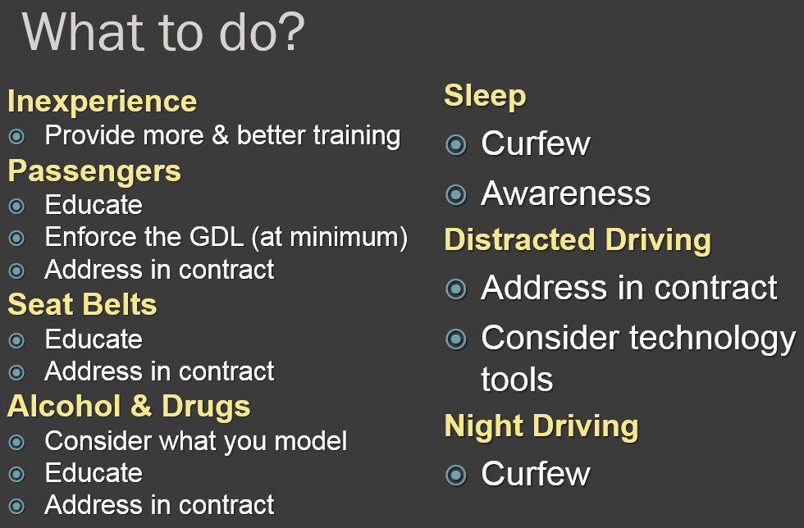
A RESPECTFUL, LEVEL-HEADED, FIRM APPROACH
You are going to be driving a vehicle that I own. I share with you the responsibility for what happens. If you have an accident, this family will share in the consequences. I have a duty to protect your safety and that of your passengers and people that could get hurt if you have an accident. This is serious business and I’m not going to enter into it without rules. The best way to be clear is to write them down. The best way for us to be aware of the seriousness of it is to sign it together. That’s a contract.

THE ALABAMA GRADUATED LICENSING LAW IN BRIEF
Applies to ALL 16-year-olds. Applies to those 17 year olds licensed less than 6 months.
Curfew: Midnight-6 a.m. with exceptions (to and from work, to and from a school/church activity, emergency)
Passenger Limit: No more than 1 passenger (does not include family members: Parents, siblings.)
No hand held communication devices while driving (no use of cell phones in motion.)

PRINT OUT THIS POSTER & PUT IT ON YOUR FRIG: http://adph.org/injuryprevention/assets/AGDLPoster.pdf

TEEN DRIVERS WITH ADHD
- are more likely to have received repeated traffic citations, most notably for speeding.
- sustain three times as many car crash injuries as teens without ADHD.
- are less likely to be practicing sound driving habits in their current driving performance, as reported by their parents.
- are nearly four times more likely to have had an accident while they were the driver of a vehicle.
- are found to be at fault for car crashes 4 times more often than peers without ADHD.
- are 6 to 8 times more likely to have their license suspended or revoked for poor driving behavior.
- are more likely to have driven an automobile without adult supervision prior to becoming licensed drivers.
Common driving errors which lead to accidents (James McKnight)
Focus on these when teaching young people to drive
- maintain attention and avoid distractions, including electronic devices in the car;
- search ahead, such as before left turns;
- search to the side, such as when yielding the right of way at an intersection;
- search to the rear, such as when changing lanes;
- adjust speed in response to traffic or road conditions;
- maintain space between their own and other vehicles, such as correct following distance;
- respond correctly to emergencies, such as recovering from a skid or sudden swerve;
- maintain basic control of the vehicle, such as keeping within a lane, braking, and turning smoothly;
- respond to traffic controls, such as traffic lights or guidance about lane use; and
- avoid driving while impaired by alcohol or sleepiness or driving a vehicle that needs repair.
WHAT’S AT STAKE?

